CYBS 7355 - Penetration Testing and Vulnerability Assessments
Mid Term Exam
Fall 2022

NAME: CHRISTOPHER PHAN
STUDENT ID: 900884326

I certify that this is my own work and I have cited all work that is not mine by quotes and citation or by paraphrasing with citations using APA. I understand that if I have plagiarized or copied materials that are not my own work that I will fail this exam with a grade of zero and be subject to academic review.

NAME: CHRISTOPHER PHAN
DATE: 09/28/2022
- For this exercise, you will work with Lab 1 – Assessing and Securing Systems on a Wide Area Network (WAN). Reduce the attack surface on TargetWindows05.
  - 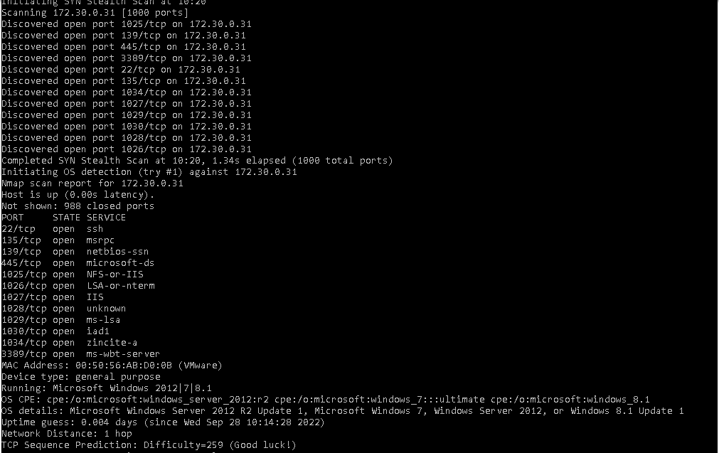
    - A nmap scan to see which ports are open on TargetWindows05 (172.30.0.31).
  - 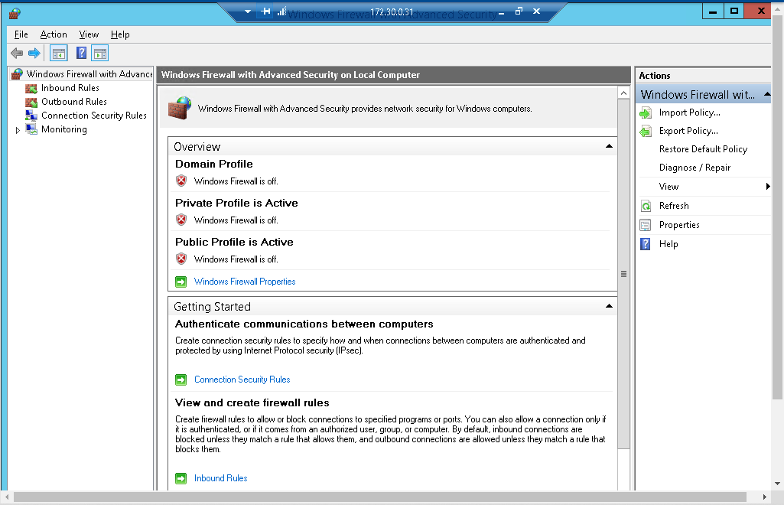
    - Opening Windows Firewall with Advanced Security on TargetWindows05.
  - 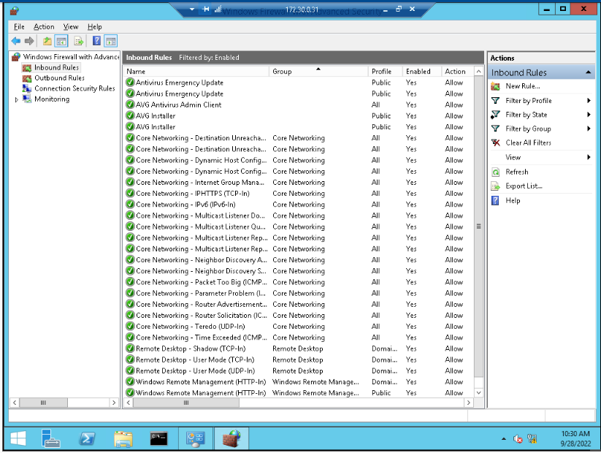
    - Looking at the inbound rules that are currently enabled on TargetWindows05.
  - 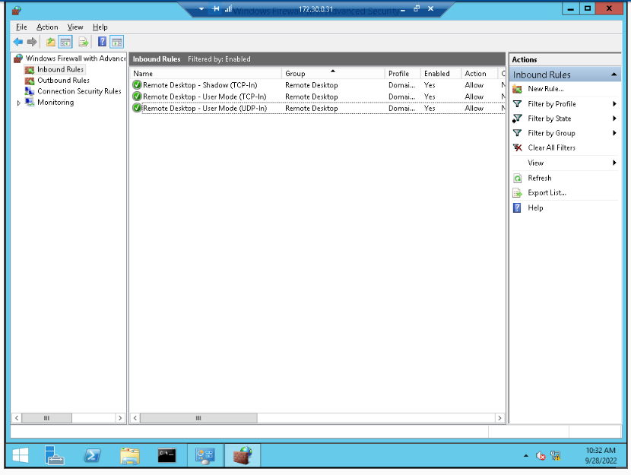
    - Disabled all inbound rules except those that concern the remote desktop inbound rules.
  - 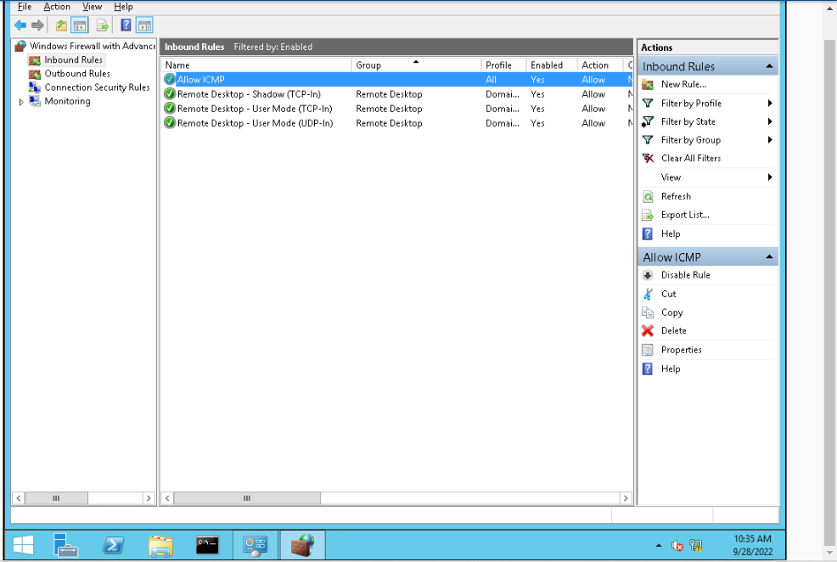
    - Created an “Allow ICMP” inbound rules on TargetWindows05.
  - 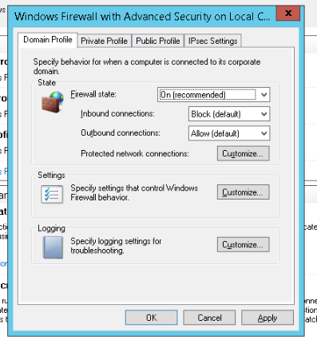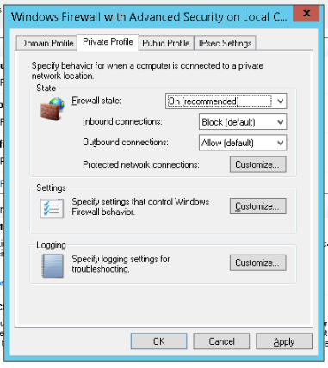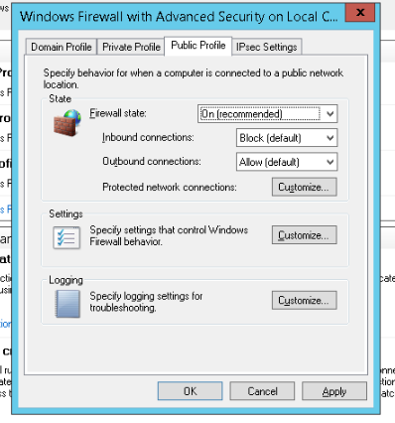
    - Turning on all the firewall states for domain profile, private profile, and public profile.
  - 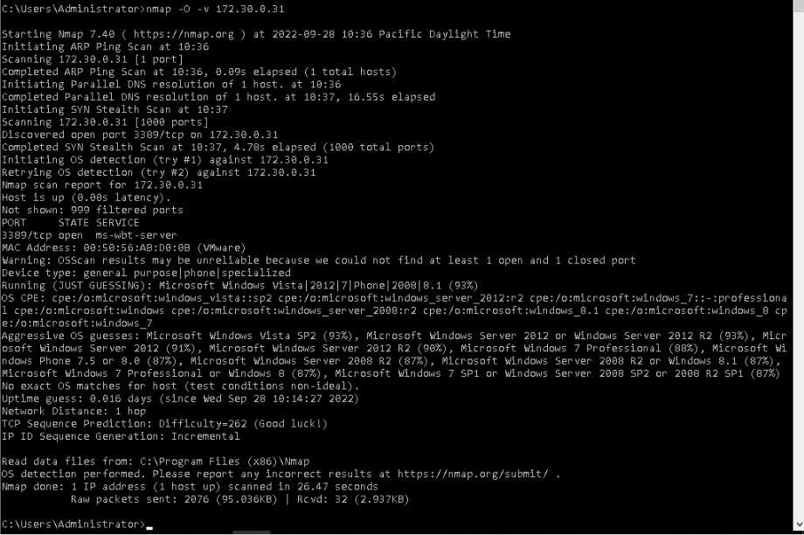
    - Checking which ports are open for TargetWindows05 after all changes created in the Windows Firewall with Advanced Security. See that port 3389 (remote desktop port) is the only one that is open, successfully showing that the attack surface on TargetWindows05 has been reduced.
- Okta is an identity and access management company. In March 2022, news of an Okta breach rattled consumer confidence. A lot of analysis has pointed to highly sophisticated activity in the hacking process. One such analysis is on Digital Shadows’ website at: https://www.digitalshadows.com/blog-and-research/the-okta-breach-what-weknow-so-far/. Use the MITRE Adversarial Tactics, Techniques, and Common Knowledge (ATT&CK) framework’s MFA resources available below to learn more about how MFA tools can be compromised. https://attack.mitre.org/techniques/T1111/. How would you go about compiling a series of steps that lists how to perform pen-testing to uncover activities of the Okta breach on your own network? (Assume that your organization uses Okta).
  - Step-by-step instructions on how to uncover malicious activities of the Okta breach through use of pen-testing.
    - Lapsus$ has a specific target vectors in that they implement: SIM-swapping attacks, insider threats, phone-based social engineering, and personal account takeovers. Okta could have implemented monitoring for three aspects: (1) proxied SIM cards, (2) API calls, and (3) windows registry keys or values concerning MFA. These are three main targets for Lapsus$ especially based on their past attacks, though this step-by-step instruction will be based around monitoring malicious activities from changes in windows registry keys or values concerning MFA.
    - Remotely changing windows registry keys and MFA values is an attack that Lapsus$ has been known to perpetuate, meaning that they have gained access through a vulnerable port or endpoint or a smart card and elevated their privileges from there. There are ways to detect if a proxy or change in windows registry keys/MFA is in use on the network.
      - First, to discover if there has been changes to Windows Registry Keys, we need to open Registry Editor (regedit).
      - Export the before and after registry branches, and name them aptly for file comparison.
      - Open Command Prompt and type in the line, changing (before) and (after) to their according names: fc c:\(before)c:\(after)>c:\log.txt. This will show if any changes have been made to the registry and if there is anything to be of concern from a remote change to the registry.
      - As well, Okta could hold a scan of their open ports currently to see if there has been a proxy connection. Using Nmap and pinging the host, if the host is reachable through the internet, it is a sign that the host is a possible proxy server having access to the network.
      - Run malware scans in case of harmful software that has been implemented remotely, which could be a rootkit allower malicious actors to take over of victim’s computer.
      - As well, disconnect all endpoints from the internet to isolate them from the network, so each one could be individually checked and see if they are the ones that are breaching the network.
- The MITRE ATT&CK framework has been used to also analyze the SolarWinds attack. https://www.crowdstrike.com/blog/sunspot-malware-technical-analysis/ Deliverables: Pick any one step of the framework as shown in the table below (also on the website) and explain it intuitively in a one-page report.
  - Defense evasion in the MITRE ATT&CK framework for the SolarWinds attack is the most significant and notable tactic of the SUNSPOT malware. This malware that was developed by StellarParticle was capable of actively evading detection by SolarWinds for nearly two years. There were four techniques that were implemented by StellarParticle to keep from being detected by security: (1) deobfuscate/decode information, (2) obfuscated files or information, (3) execution guardrails, and (4) masquerading. What deobfuscate/decode information entails the SUNSPOT malware searching through the solution directory for key pieces of information that StellarParticle wanted, and decoding that information into data that is legible and usable to those malicious actors. Obfsucating files meant how SUNSPOT had an encrypted log file named vmware-vmdmp.log, which was ciphered by RC4. These encrypted files were hidden away, as well could not have been accessed without understanding the malware, which SolarWinds did not even know had breached their network. Execution guardrails meant how SUNSPOT replacing source code had to match the original source code file with their backdoor replacement so SolarWinds would not be able to not find the insertion of a unauthorized backdoor. Matching the source codes was vital for this operation as it allowed StellarParticle to go unnoticed for such a long period of time. Lastly, masquerading was one of the key techniques that allowed SUNSPOT to operate discreetly, as it acted as a real Windows Binary system, creating the vmware log file mentioned previously. This masquerading would trick SolarWind’s security into thinking the system was working as it was supposed to do, and in doing so, did not think that there was a malware manipulating the system in creating a illegitimate backdoor and false encrypted log files. This defense invasion was what enabled StellarParticles to be in SolarWind’s system for two years without anyone realizing.
- For this exercise, you will work with Lab 3– Data Gathering and Footprinting on a Targeted Website. How can you identify the physical location of an IP address? Identify the physical location of the servers for the three domains you explored in the lab and the Bitcoin domain (btc.us). Additionally, identify the physical location of the server for a different website of your choosing. Use a pen-testing tool that you are familiar with and see what you can find out about that server using your tool.
  - I use an API website for finding physical locations of IP addresses: https://incolumitas.com/pages/IP-API/. I simply input the IP address and the program will automatically run a series of test about that IP address. For me to find those IP addresses, I use Sam Spade application since it is capable of presenting various information about domains.
  - There will be 5 targets to find their physical location from their IP address:
    - Apple.com
      - 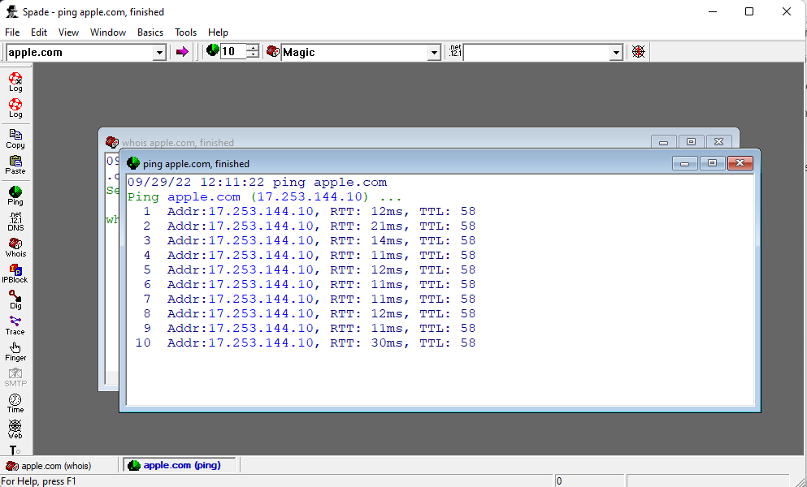
      - IP address is 17.253.144.10
      - Physical address is latitude 37.3219, longitude -122.03, meaning it would be 10144 Macadam Lane, Cupertino, California 95014.
    - Microsoft.com
      - 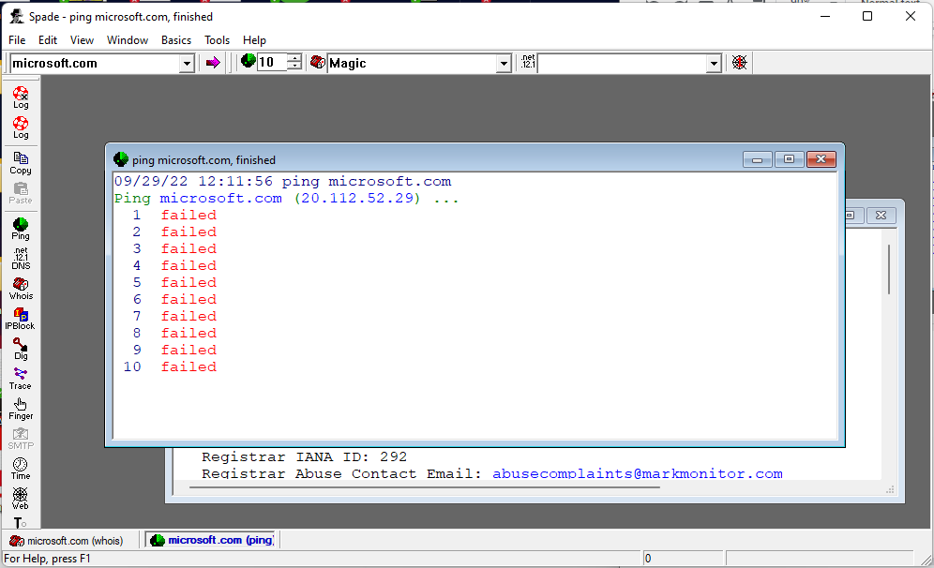
      - IP address is 20.112.52.29
      - Physical address is latitude 47.2343, longitude -119.853, meaning that it would be 402 Central Avenue South, Quincy, WA 98848.
    - Facebook.com
      - 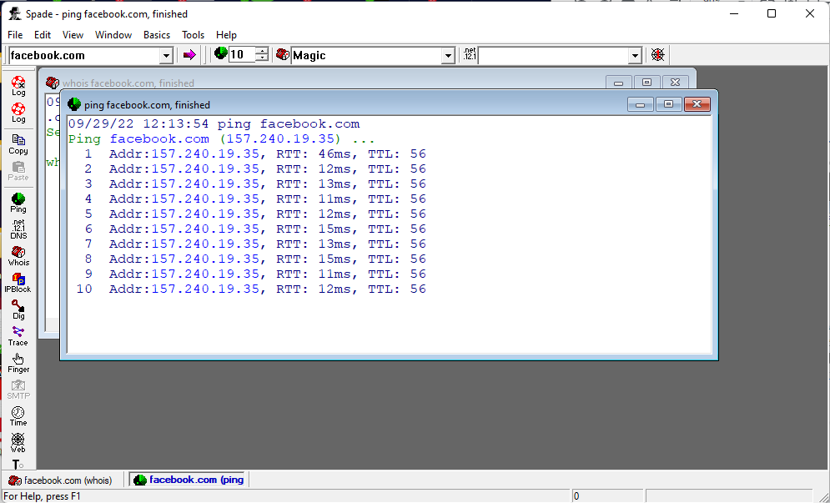
      - IP address is 157.240.19.35
      - Physical address is latitude 32.7767, longitude -96.797, meaning that it should be Marilla Street, Dallas, TX 75201.
    - Btc.us
      - 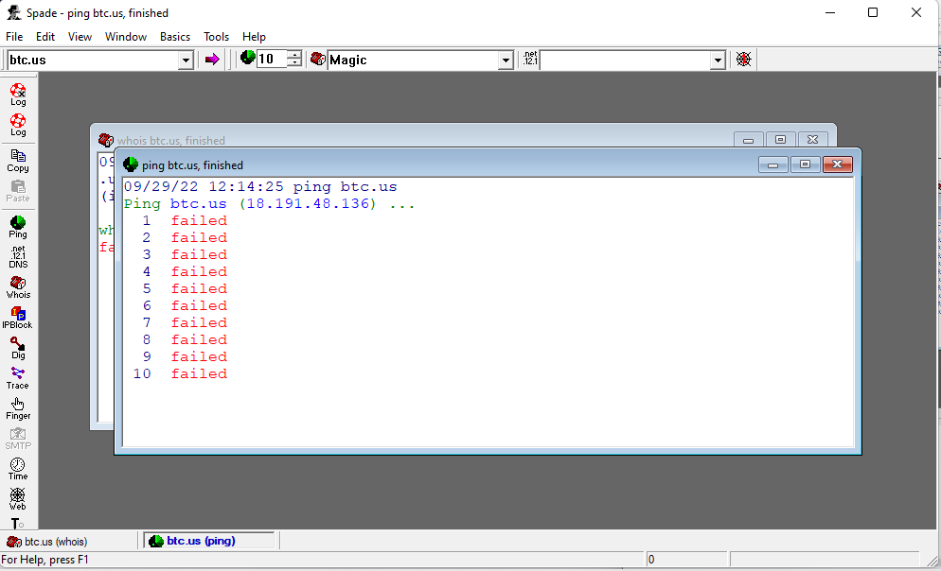
      - IP address is 18.191.48.136
      - Physical address is latitude 40.0992, longitude -83.1141, meaning that it should be 41 West Bridge Street, Dublin, OH 43017.
    - Bigmode.com (My chosen website)
      - 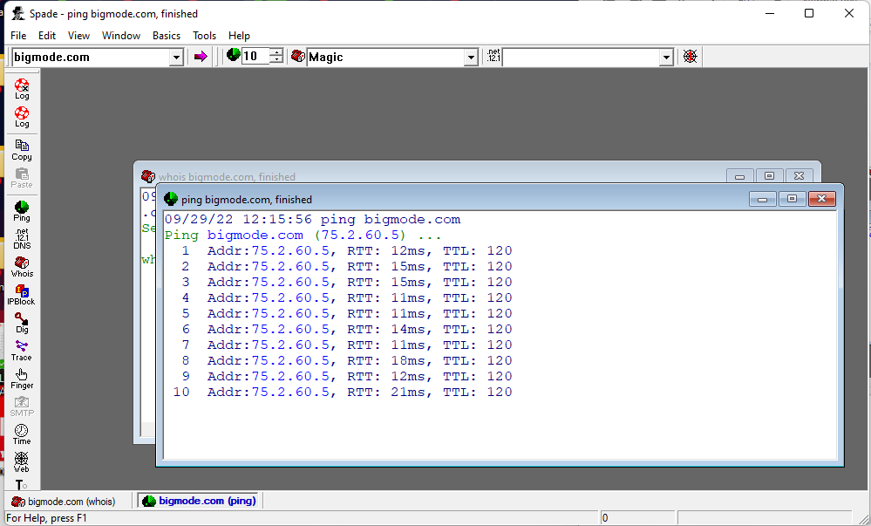
      - IP address is 75.2.60.5
      - Physical address is latitude 47.6229, longitude -122.337, meaning that it should be 440 Terry Avenue North, Seattle, WA 98109.
      - 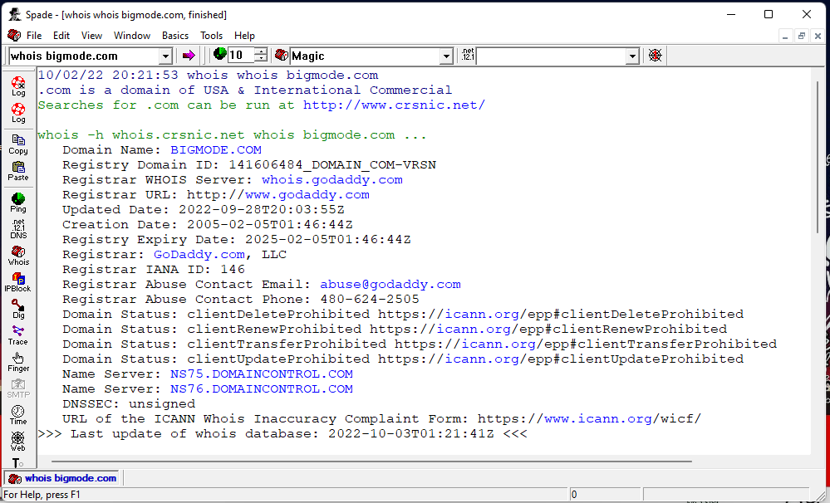
        - Here is a WHOIS of bigmode.com, showing more information of the server that holds bigmode.com
      - 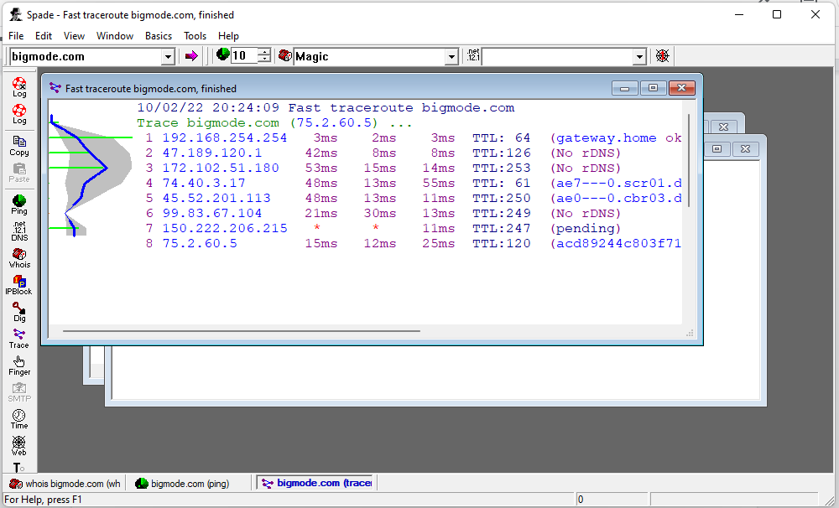
        - Showing the traceroute to bigmode.com from my IP address all the way to the domain’s IP address.

